Musings on Bealtaine 2020
Bealtaine
Somebody asked for tips on what to do for Bealtaine this year – 2020. Of course we won’t be meeting in person this year because of a certain virus, but just as our meditation nights are continuing through lockdown using the wonders of modern technology, so we’ve decided to host our own personal Bealtaine Celebrations and post photos/videos of them online to share with our friends worldwide.

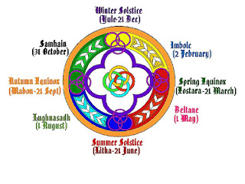
This Photo by Unknown Author is licensed under CC BY

Bealtaine falls exactly between the Spring Equinox and the Summer Solstice (it’s also exactly between the Winter and Summer Solstices) and is the mid-point of the ancient “year” which began after Samhain around the end of October. It signals a time of Fertility, Sunshine, Fire, Light and Abundance and was Celebrated by our Ancestors as a particularly important festival in the Wheel of the Year. In Ireland, there was a huge Fire Festival at Uisneach – a tradition which is carried on to this day. (It won’t be held this year but if you’ve never been, a visit to the Uisneach Fire Festival is highly recommended).

What to do?
When thinking of Bealtaine one thinks of Fire because as well as being an ancient “Fire Festival” one interpretation of the name comes from the Irish (Gaelige) words “Béal” meaning mouth and “Tine” which means fire. Therefore, it might be an idea to light a (small) fire in your garden – an old biscuit tin is an ideal substitute if you haven’t got a cauldron – and have your own personal ceremony. (Obviously, take care not to create too much smoke, we don’t want to be upsetting the neighbours!) At first, I would recommend opening your ceremonial “circle” simply by calling in ancestors, spirits, angels, elements or whatever you feel like to help you celebrate. It is quite common to also invoke the Spirits of the Directions (East, South, West and North) to join the party after which it is quite easy to stand there at your little fire (or in front of a candle indoors if it’s raining) and do a quiet meditation about Summer or Light or Fertility…or anything that “feels” right. You could also use a symbol or symbols to enhance your experience.
Micro to Macro – Virus to the Sun
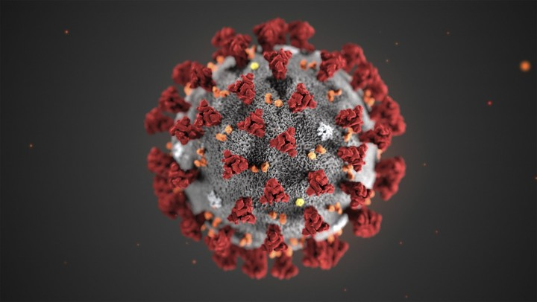
This Photo by Unknown Author is licensed under CC BY-NC-ND

For me, personally, there’s TWO symbols I’m going to use. One (above) is the Corona Virus, that tiny little thing that has caused so much heartache and panic around the world. The other (below) is the only Corona I want to be focussed on – the Suns Corona. I intend to have a picture of our little Pandemic-causing virus and I will gladly throw it into my mini bonfire which will represent our nearest friendly star, the Sun. Symbolically, the virus will perish at the hands of the Sun who will continue as usual to bathe our Earth with life-giving sunlight.

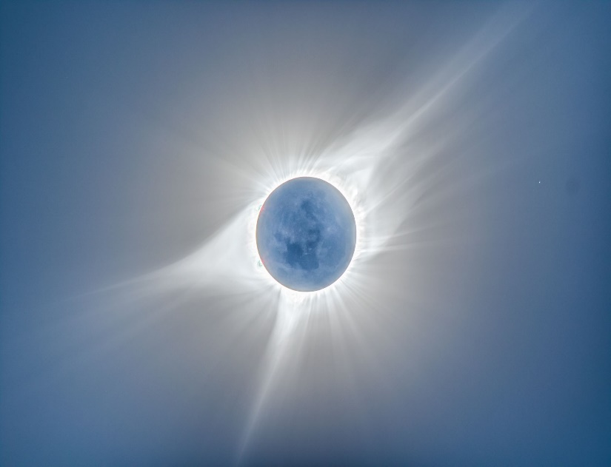

When that’s done, I’ll celebrate by sending healing around the world knowing that I am not alone because I’m being joined by fellow Light-Beings who are sending out similar intentions globally.
I will then thank the Ancestors, Spirit-World, Mother Earth, Father Sky, Universe, Source, God (insert whatever word you are comfortable with here) not forgetting of course the Sun. Then, that’s it! Ceremony over, close the Circle if you wish, reflect for a while and log on to post your Bealtaine adventure online in words, pictures, videos or simply to just touch base with other like-minded folk here in the Tara Celebrations family. (Taracelebrations.org, Facebook, WhatsApp etc.).
These Celebrations are a time of personal reflection as well as a Celebration of the wonders of Nature and the Universe. Regarding the reflection, it could be a time to reflect on positivity, light, sunshine and such-like. Our Ancestors were extremely close to Nature and perhaps we can use these lockdown times to get back closer to Nature ourselves. Sit in the garden or balcony without a screen and look at the sky, listen to the birdsong, feel the breeze. Remember what is REALLY important and what we REALLY miss at the moment (Hint: what we miss usually doesn’t involve money, work or “stuff”!) and resolve to remember these things when we are all “released”. Things such as a walk on the beach with friends, a hug, handshake or kiss. A stroll to the local and a pint with a friend, a coffee and scone and a chat with a loved one, a meal with work colleagues. It’s also a time for gratitude for what we have even in the trying times we find ourselves in at the moment – things like Life, Health, Sunshine, Technology, Food, Family, Flowers, Hope…the list is actually endless.
Finally, I’ll leave you with this thought which is pertinent as we watch Mother Earth actually thrive while we humans are struggling. Examples of this can be seen in reports all over the world – The Himalayan mountains visible to folk in Indian cities for the first time in a decade because of lack of air pollution, animals, fish and birds being spotted in places they haven’t been for decades and clearer skies because there’s very little air traffic. The message from Mother Earth is simple and direct:
“Remember, you are my guests, not my masters”.

